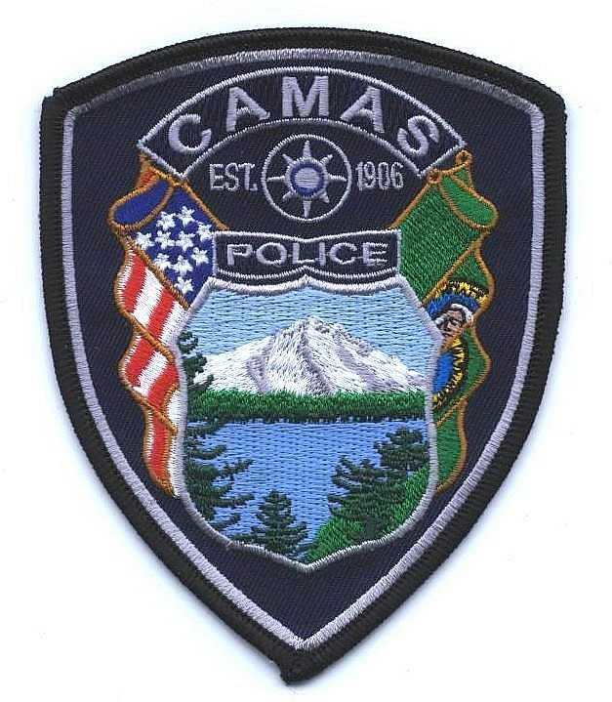
Camas Police Department
MEMO
January, 2021
To: Chief Lackey
From: Captain Nelson
Subject: Pursuit Review for 2020

There were two pursuit reviews in 2020, with each pursuit having a different initiating officer. The first pursuit involved a subject who was likely burglarizing a home under construction. The second pursuit involved a speeding vehicle that was later determined to be stolen.

Administrative Review 20-05
Camas Officers were dispatched to a theft in progress at a construction site. An officer located the vehicle that took off at a high rate of speed. The officers initially gave chase but terminated the pursuit within 60 seconds. The officers were determined to not have engaged in the pursuit beyond an initial assessment of the crime at hand. The involved officers recognized our policy does not allow pursuits for property crimes. There were no policy violations.

Administrative Review 20-40
A brand new officer attempted to stop a speeding vehicle. The vehicle continued at a high rate of speed through neighborhoods and the officer continued to give chase. The officer also continued to speed through neighborhoods following the suspect vehicle after he terminated the pursuit. The officer had lost sight of the vehicle, but ultimately located the vehicle crashed along the roadway. Ultimately, the officer initially engaged in a pursuit for a speeding infraction, which is not supported by policy. The officer was found to be in violation of both initiating and terminating pursuit policies. The officer received a verbal warning.

